## Median Table By Country

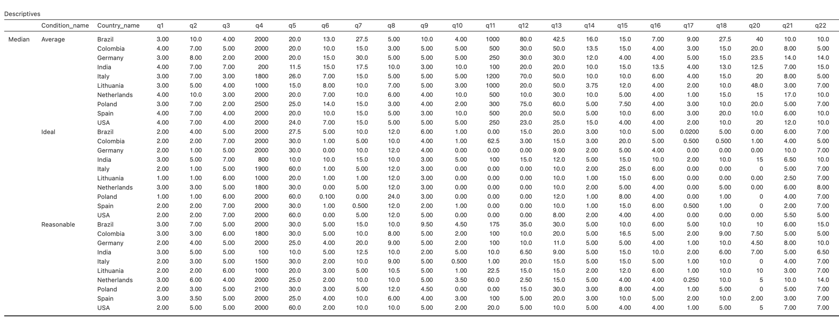

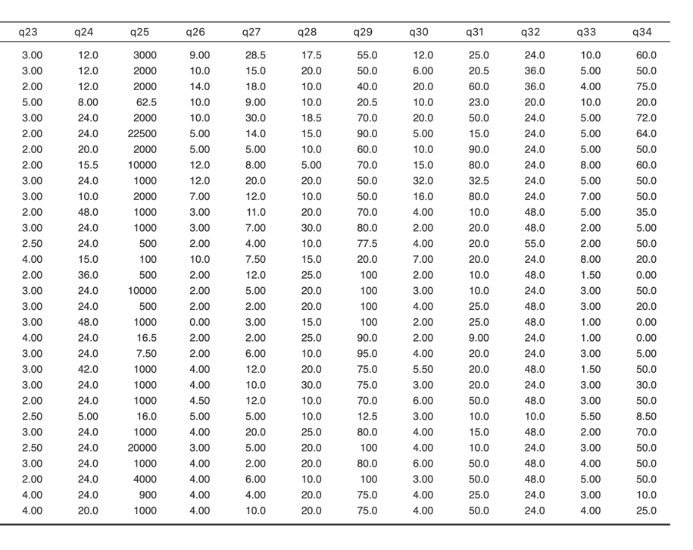

## Median Table Overall

## 

## **AIC Values**

**Overall Model AIC**

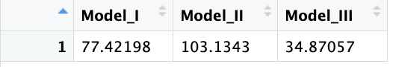

**By Country Model AIC**

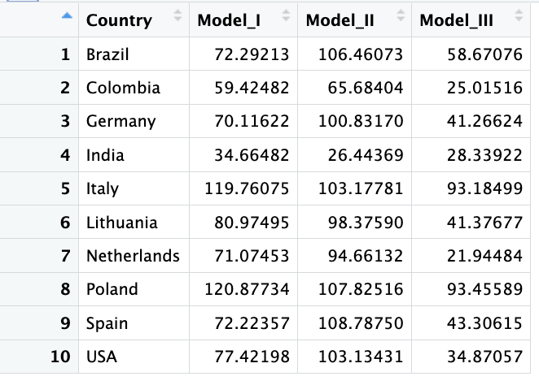

(Model I) average predicts reasonable

(Model II) ideal predicts reasonable

(Model III) both average and ideal predict reasonable judgments

## **Binomial Test for Overall Conditions – Assuming Unequal**

## This is a description of what the code is doing, where I am calculating if the “side” of reasonable is below or above, not whether it is are *at* or below or *at* or above the ideal or average side.

*Binomial Test of Ideal Side of Average (at greater than 50%)*

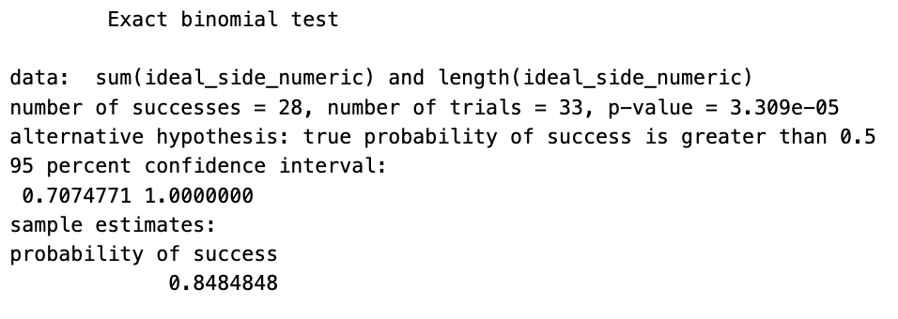

*Binomial Test of Average Side of Ideal (at greater than 50%)*

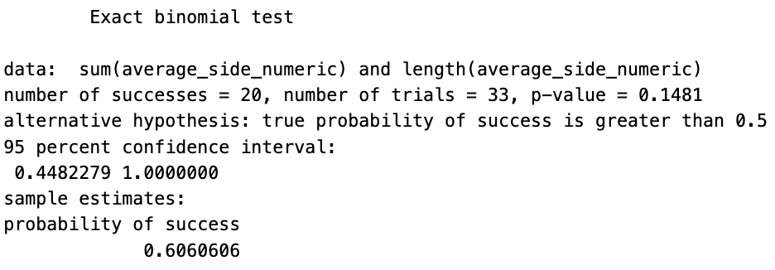

*Binomial Test of Both on the Ideal Side of Average and Average Side of Ideal (at greater than 1/3 chance)*

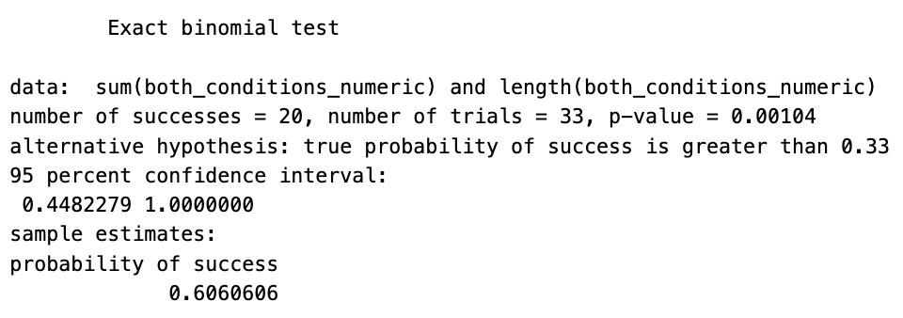

## **Binomial Test for Overall Conditions – Assuming Equal**

## This is a description of what the code is doing, where I am calculating if the “side” of reasonable is *at* or below or *at* or above the ideal or average side, not below or above.

*Binomial Test of Ideal Side of Average (at greater than 50%)*

*Binomial Test of Average Side of Ideal (at greater than 50%)*

*Binomial Test of Both on the Ideal Side of Average and Average Side of Ideal (at greater than 1/3 chance)*

## **Binomial Test for Each Country – Assuming Unequal**

***Brazil***

*Binomial Test of Ideal Side of Average (at greater than 50%)*

*Binomial Test of Average Side of Ideal (at greater than 50%)*

*Binomial Test of Both on the Ideal Side of Average and Average Side of Ideal (at greater than 1/3 chance)*

***Colombia***

*Binomial Test of Ideal Side of Average (at greater than 50%)*

*Binomial Test of Average Side of Ideal (at greater than 50%)*

*Binomial Test of Both on the Ideal Side of Average and Average Side of Ideal (at greater than 1/3 chance)*

***Germany***

*Binomial Test of Ideal Side of Average (at greater than 50%)*

*Binomial Test of Average Side of Ideal (at greater than 50%)*

*Binomial Test of Both on the Ideal Side of Average and Average Side of Ideal (at greater than 1/3 chance)*

***India***

*Binomial Test of Ideal Side of Average (at greater than 50%)*

*Binomial Test of Average Side of Ideal (at greater than 50%)*

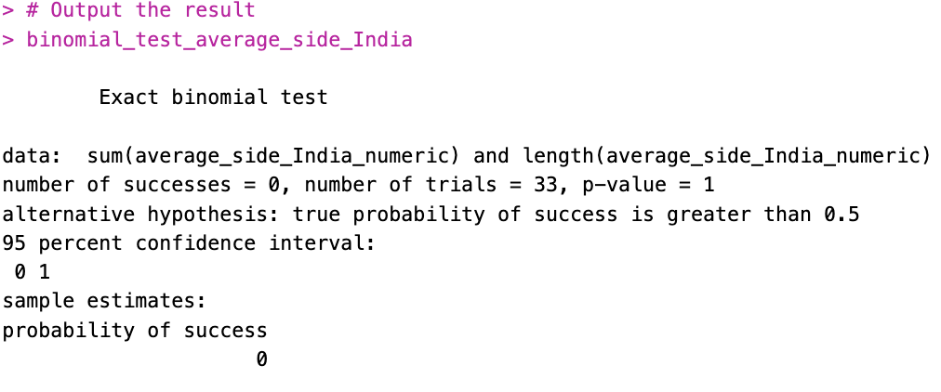

*Binomial Test of Both on the Ideal Side of Average and Average Side of Ideal (at greater than 1/3 chance)*

***Italy***

*Binomial Test of Ideal Side of Average (at greater than 50%)*

*Binomial Test of Average Side of Ideal (at greater than 50%)*

*Binomial Test of Both on the Ideal Side of Average and Average Side of Ideal (at greater than 1/3 chance)*

***Italy***

*Binomial Test of Ideal Side of Average (at greater than 50%)*

*Binomial Test of Average Side of Ideal (at greater than 50%)*

*Binomial Test of Both on the Ideal Side of Average and Average Side of Ideal (at greater than 1/3 chance)*

***Lithuania***

*Binomial Test of Ideal Side of Average (at greater than 50%)*

*Binomial Test of Average Side of Ideal (at greater than 50%)*

*Binomial Test of Both on the Ideal Side of Average and Average Side of Ideal (at greater than 1/3 chance)*

***Netherlands***

*Binomial Test of Ideal Side of Average (at greater than 50%)*

*Binomial Test of Average Side of Ideal (at greater than 50%)*

*Binomial Test of Both on the Ideal Side of Average and Average Side of Ideal (at greater than 1/3 chance)*

***Poland***

*Binomial Test of Ideal Side of Average (at greater than 50%)*

*Binomial Test of Average Side of Ideal (at greater than 50%)*

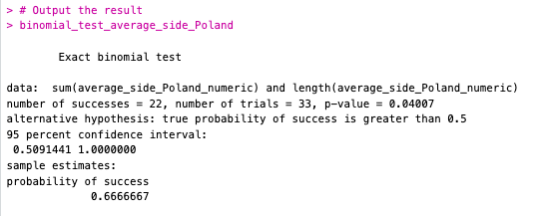

*Binomial Test of Both on the Ideal Side of Average and Average Side of Ideal (at greater than 1/3 chance)*

***Spain***

*Binomial Test of Ideal Side of Average (at greater than 50%)*

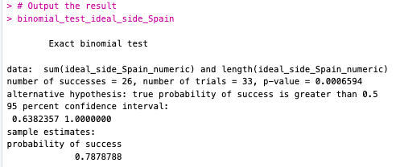

*Binomial Test of Average Side of Ideal (at greater than 50%)*

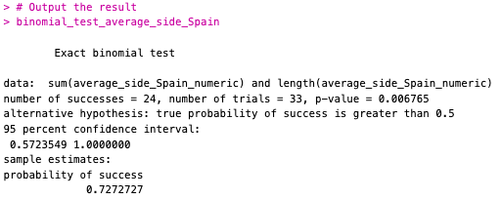

*Binomial Test of Both on the Ideal Side of Average and Average Side of Ideal (at greater than 1/3 chance)*

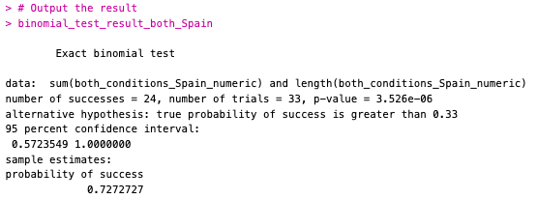

***USA***

*Binomial Test of Ideal Side of Average (at greater than 50%)*

*Binomial Test of Average Side of Ideal (at greater than 50%)*

*Binomial Test of Both on the Ideal Side of Average and Average Side of Ideal (at greater than 1/3 chance)*

## **Binomial Test for Each Country – Assuming Equal**

***Brazil***

*Binomial Test of Ideal Side of Average (at greater than 50%)*

*Binomial Test of Average Side of Ideal (at greater than 50%)*

*Binomial Test of Both on the Ideal Side of Average and Average Side of Ideal (at greater than 1/3 chance)*

***Colombia***

*Binomial Test of Ideal Side of Average (at greater than 50%)*

*Binomial Test of Average Side of Ideal (at greater than 50%)*

*Binomial Test of Both on the Ideal Side of Average and Average Side of Ideal (at greater than 1/3 chance)*

***Germany***

*Binomial Test of Ideal Side of Average (at greater than 50%)*

*Binomial Test of Average Side of Ideal (at greater than 50%)*

*Binomial Test of Both on the Ideal Side of Average and Average Side of Ideal (at greater than 1/3 chance)*

***India***

*Binomial Test of Ideal Side of Average (at greater than 50%)*

*Binomial Test of Average Side of Ideal (at greater than 50%)*

*Binomial Test of Both on the Ideal Side of Average and Average Side of Ideal (at greater than 1/3 chance)*

***Italy***

*Binomial Test of Ideal Side of Average (at greater than 50%)*

*Binomial Test of Average Side of Ideal (at greater than 50%)*

*Binomial Test of Both on the Ideal Side of Average and Average Side of Ideal (at greater than 1/3 chance)*

***Lithuania***

*Binomial Test of Ideal Side of Average (at greater than 50%)*

*Binomial Test of Average Side of Ideal (at greater than 50%)*

*Binomial Test of Both on the Ideal Side of Average and Average Side of Ideal (at greater than 1/3 chance)*

***Netherlands***

*Binomial Test of Ideal Side of Average (at greater than 50%)*

*Binomial Test of Average Side of Ideal (at greater than 50%)*

*Binomial Test of Both on the Ideal Side of Average and Average Side of Ideal (at greater than 1/3 chance)*

***Poland***

*Binomial Test of Ideal Side of Average (at greater than 50%)*

*Binomial Test of Average Side of Ideal (at greater than 50%)*

*Binomial Test of Both on the Ideal Side of Average and Average Side of Ideal (at greater than 1/3 chance)*

***Spain***

*Binomial Test of Ideal Side of Average (at greater than 50%)*

*Binomial Test of Average Side of Ideal (at greater than 50%)*

*Binomial Test of Both on the Ideal Side of Average and Average Side of Ideal (at greater than 1/3 chance)*

***USA***

*Binomial Test of Ideal Side of Average (at greater than 50%)*

*Binomial Test of Average Side of Ideal (at greater than 50%)*

*Binomial Test of Both on the Ideal Side of Average and Average Side of Ideal (at greater than 1/3 chance)*

